Assignment – 03:
Create IAM user and give full access to S3.

Steps:
- Search for IAM in the search bar and click on the Roles under the Top Features under the IAM service option.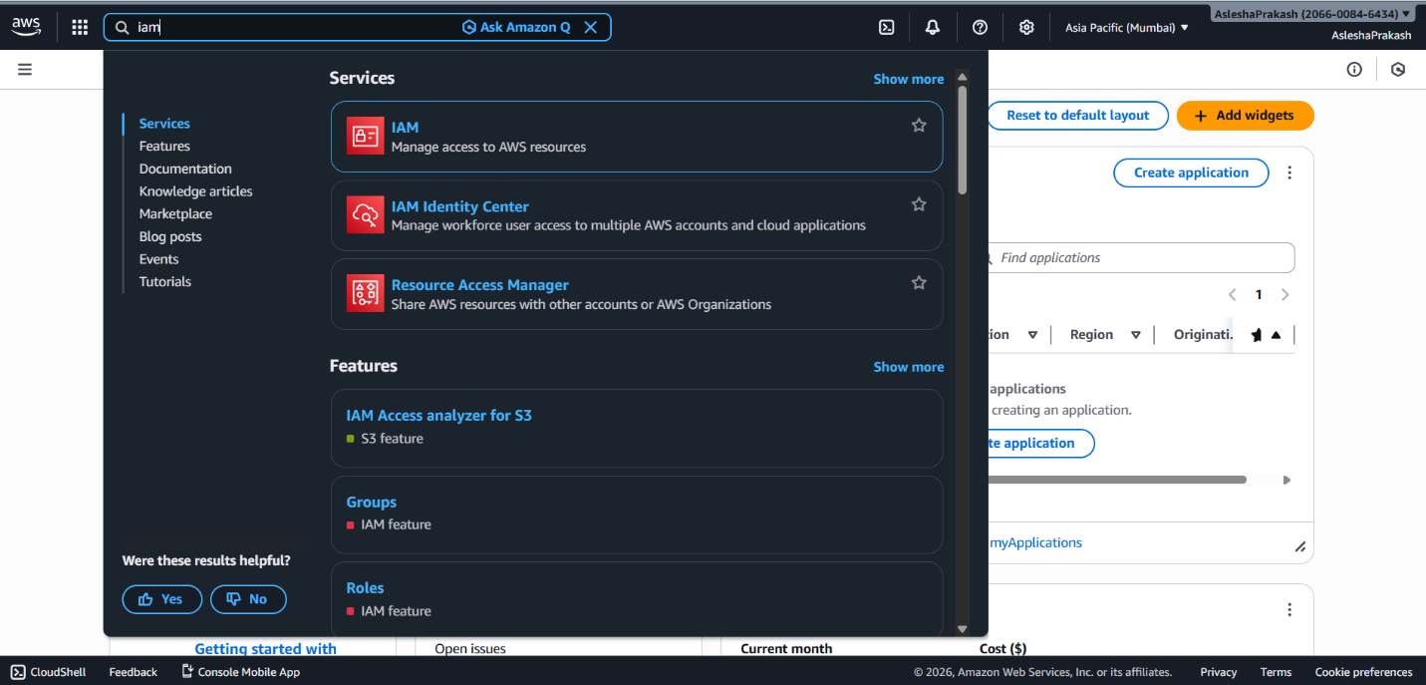

- Enter the user details and click Next.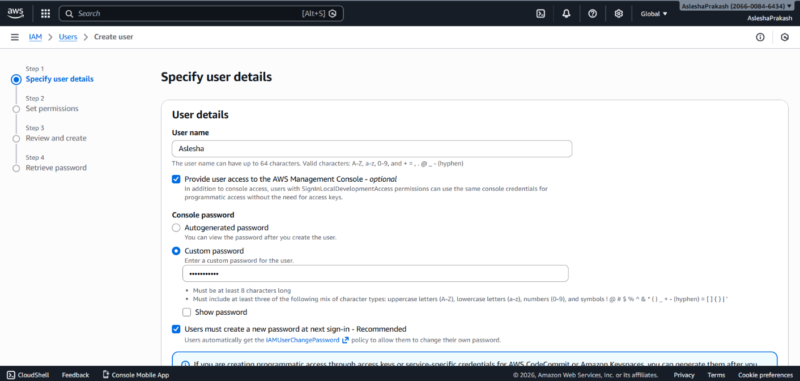

- Set permissions. We will choose “Add user to group” in Permission options and then click on Create group.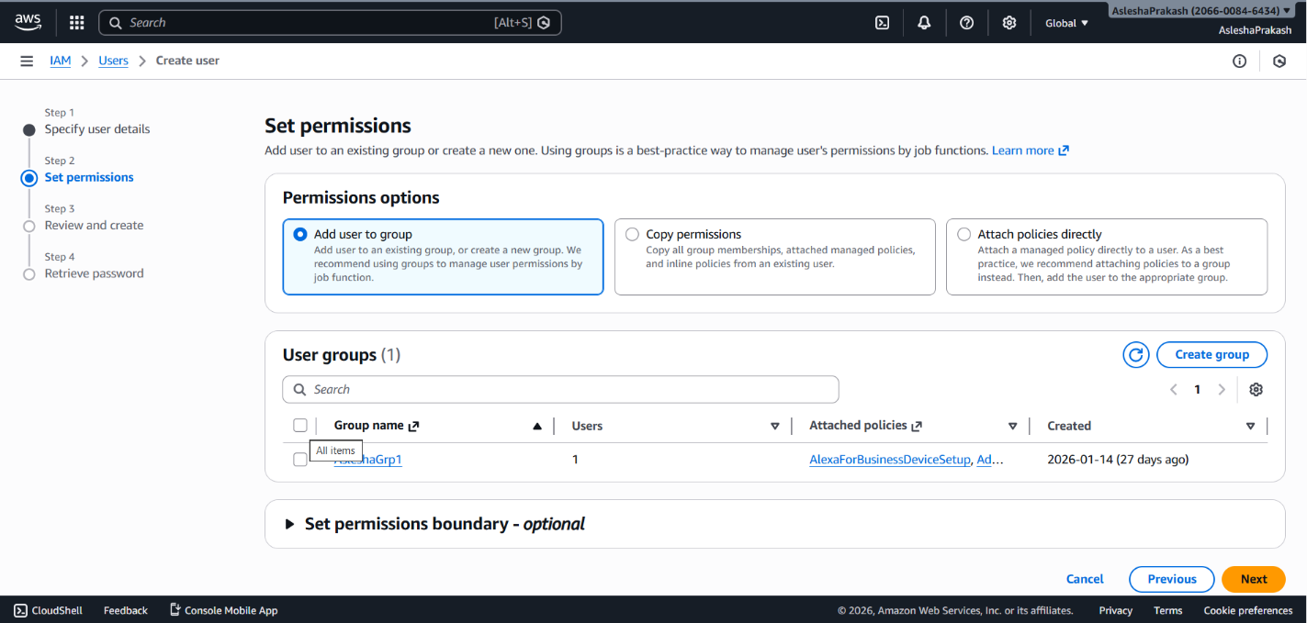

- Enter a user group name and select all the policies which appear on filtering out on basis of s3 and then click Create user group button.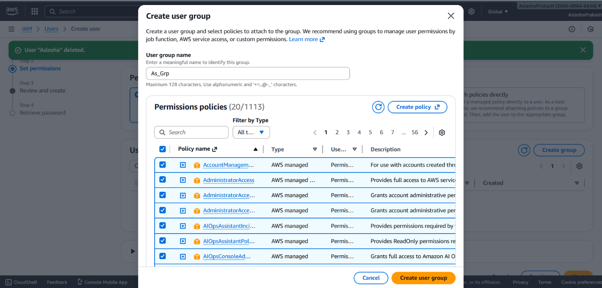

- Select the user group just created or any desired group and then click on Next button.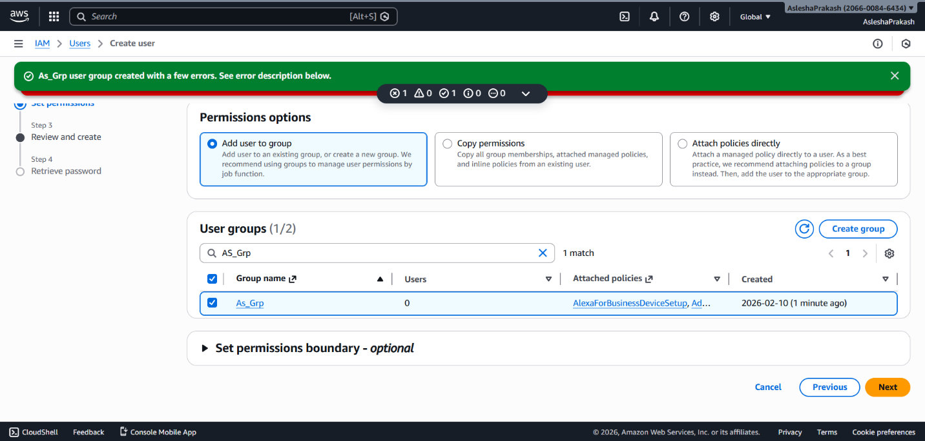

- Review the user details and permissions and click on Create user button. This successfully creates an IAM user with full access to S3 services.